**PayProcessMD**

Doctor’s payroll processing, done right.

**User Guide**

**v1.0**

Asian Hospital and Medical Center 2018

**Overview**

PayProcessMD is an on-premise web application that is built to process doctors’ payroll. It is based from the current doctor’s fee system but is more highly optimized, user friendly, accurate and flexible. This application requires internet connection and can be accessed via this url, <http://payprocessmd>.

**Application Core**

PayProcessMD is simply divided into 4 core divisions.

REPORTS

UPLOADING

PROCESSING

MAINTENANCE

**1. Maintenance**

**A. Login**

PayProcessMD is designed to authenticate users against the Active Directory therefore, a domain account is needed to access this system.

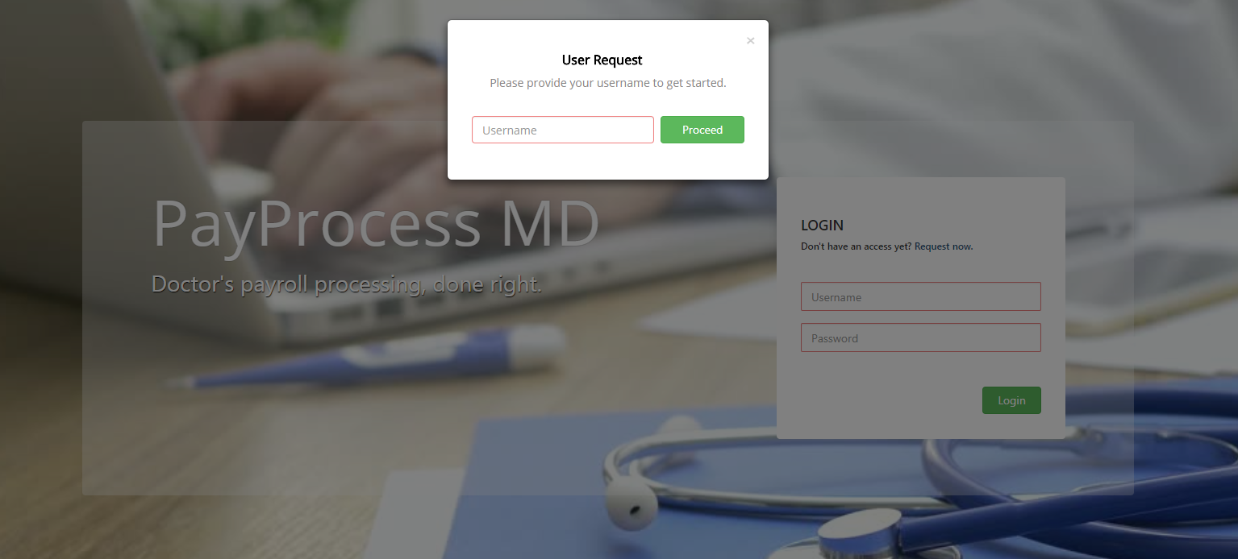**B. User Request**

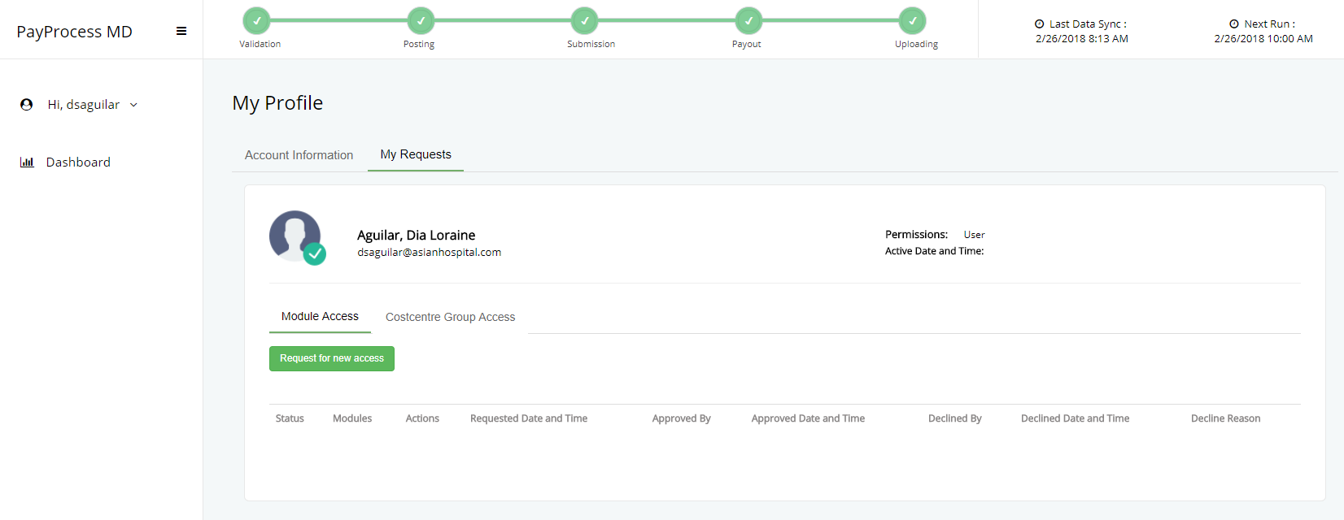

A domain account does not guarantee an automatic access to the system so users need to request access to either one or multiple modules and actions.

**Steps for requesting an access.**

1. Click the *Request Now* link in the login page.
2. Enter the domain username.
3. Once the system has validated the domain username, user may proceed in selection of desired modules and actions.
4. Click the *Request* button.
5. Enter the domain password to ensure user’s identity.
6. Once the system has validated the domain password, an email notification will

be sent to both the user requestor and module approver.

Once the request is approved, user can now login and any other additional request for access can be done inside the system.

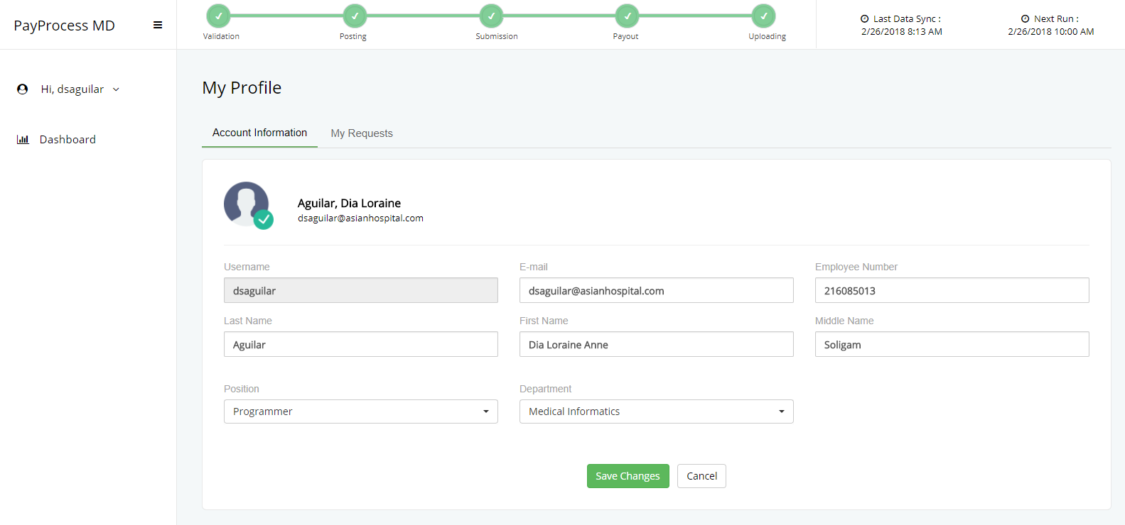**C. User Profile**

User information is vital to the system so users need to complete their details in the User Profile Module once logged in. For employees who owns an Orion HIS account, the system will auto-fill the required fields, in case the information from the HIS is not updated, the user can modify and save his changes. The system will detect any incomplete detail in the User Profile module and will prompt the user to fill it up for every login.

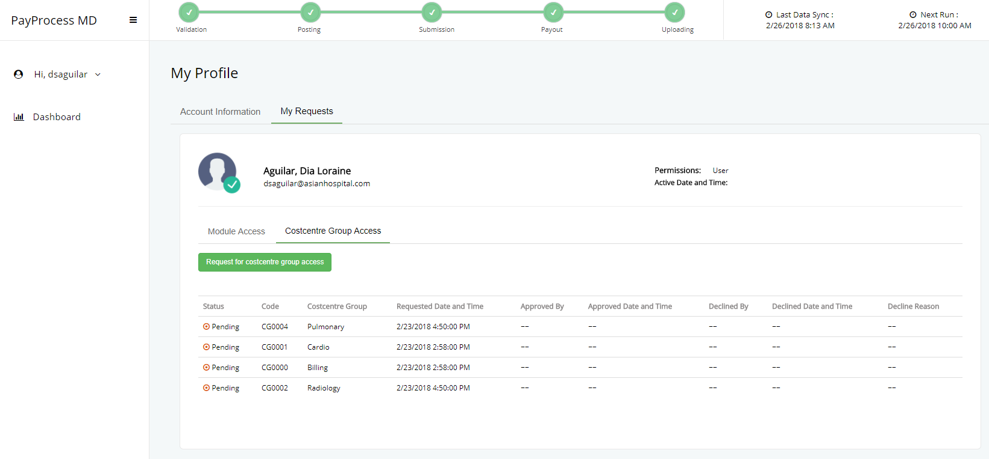**D. Costcentre Group**

User’s default costcentre group is automatically identified based on the department specified in User Profile Module. When the need arises specially for validators, user can request for multiple costcentre group.

**Steps for requesting an additional costcentre group.**

1. Navigate to *User Profile* module.
2. Click the *My Requests* tab.
3. Proceed to the *Costcentre Group Access* tab.
4. Click the *Request for coscentre group access* button.
5. Choose the desired costcentre group then *Submit*, an email notification will be

sent to both the user requestor and module approver.

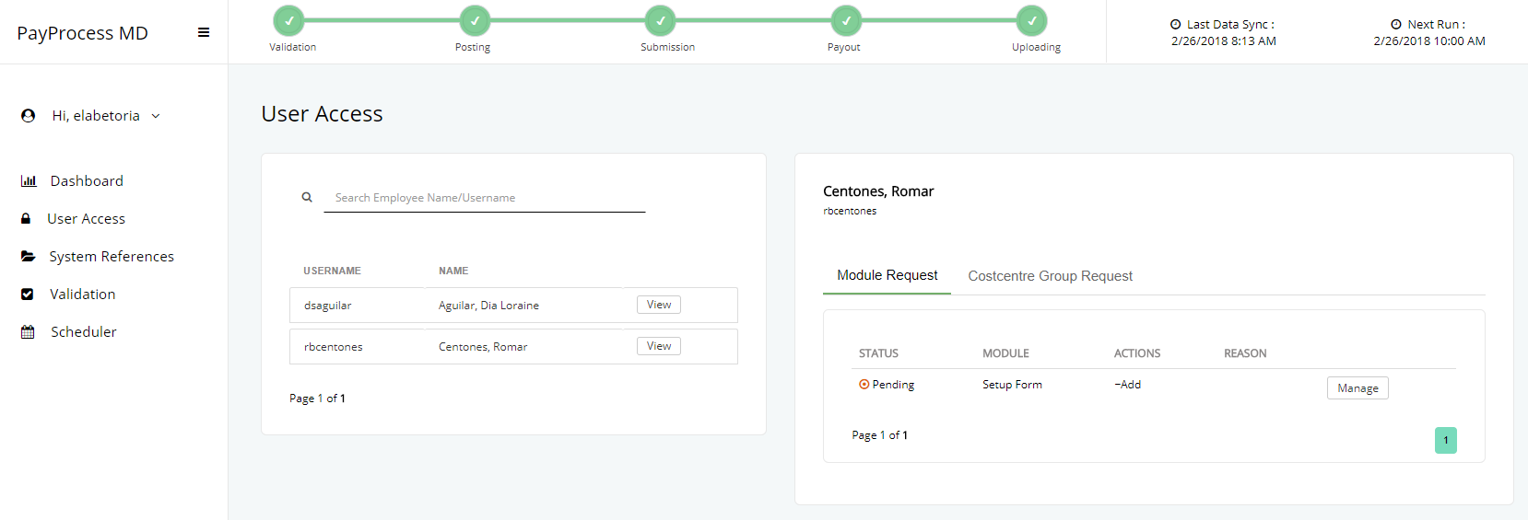**E. Request Approval**

Assigned approvers for each module and costcentre can view all the requests in the*Access Requests*module. This also sends an email notification to the requestor with regards to the status of his request.

**How to approve an access request?**

1. Click *View* button to see all requests made by a user.
2. Choose desired request then click *Manage*, if there are no changes

needed, select *Approve* and confirm the action made once the modal

dialog pops up but if the approver wishes to modify the request, select

*Modify* then proceed to approval.

1. The status of the request will now refect in the table.

**How to decline/revoke an access request?**

1. Click *View* button to see all requests made by a user.
2. Choose desired request then click *Manage* and select *Decline/Revoke*.
3. Provide a reason once the modal dialog pops up then confirm the action

made.

1. The status of the request will now reflect in the table.

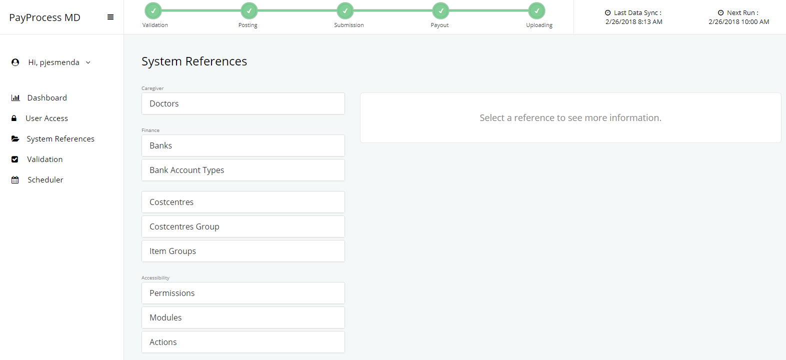**F. System References**

All references, settings and configurations for PayProcessMD can be found in this module. This allows the system to be dynamic and flexible.

**F.1 Doctors**

This contains the list of all doctors from Orion HIS, summarized subsidary ledger and bank accounts.

**Bank Accounts**

Enables authorized user to create, edit and deactivate doctor’s bank accounts.

**Steps in creating bank account.**

1. Choose the desired doctor then click *Bank Accounts*.
2. Click *Create*. To get started.
3. Add an account by selecting a bank from the available options in the dropdown menu.
4. Provide doctor’s bank account number. (Please make sure that the entered account number is accurate.)
5. Click *Save*, the newly created account will be automatically set as active.

**Steps in editing/deactivating bank account.**

1. Choose the desired doctor then click *Bank Accounts*.
2. Click the *Manage* button for the selected bank account.
3. Choose *Edit/Deactivate*.

**Subsidiary Ledger**

Displays subsidiary ledger entries of a specific doctor. The summary shows the total amount that should be credited to a Doctor since the first payout.

**Demographics**

Shows the basic information of a specific doctor. Data is both taken from Orion and PayProcessMD.

**Details pulled from Orion HIS**

* Full name
* Date of birth
* Gender
* Address
* Post code
* Employee Number
* Phone Number
* Specialty
* Department
* Job Type
* Job Category
* Hired Date
* Tax Number

**Details from PayProcessMD**

* *Vatable* indicator
* Withholding Tax Rate
* *BIR Sworn Statement* indicator
* *Skip Checking of Taxable Amount* indicator
* Payee Type
* Remittance Type

**F.2 Banks**

Lists all credited banks that can be used in creation of doctor’s bank accounts.

**Steps in creating a bank.**

1. Click *Create* to get started.
2. Provide a bank name then *Save*.

**Steps in editing/deleting a bank.**

1. Click *Manage* button for the selected bank.
2. Choose *Edit/Delete*.

**F.3 Costcentres**

Displays all costcentres from Orion HIS.

**F.4 Costcentre Groups**

Enables user to create custom groups, manage them, set an approver and tag items as exclusive for a certain group.

**Steps in creating group.**

1. Click *Create* to get started.
2. Provide a costcentre group description then *Save*.
3. After creation, click *Costcentre* for the newly created group.
4. Add costcentre(s) from the available options in the dropdown menu.

**Steps in editing/deleting group.**

1. Click *Manage* button for the selected group.
2. Choose *Edit/Delete*.

**How to set an approver for a group?**

1. Click *Approvers* for the selected group.
2. Add approver(s) from the available options in the dropdown menu.

**How to set item as exclusive for a group?**

1. Click *Item Group* for the selected group.
2. Toggle the *Exclusive* field on/off for the desired item.

**F.5 Permissions**

Displays all permissions available for users of PayProcessMD

**F.6 Modules**

Displays all modules available in PayProcessMD and allows authorized users to assign approvers for modules.

**Steps in assigning approvers for modules.**

1. Click *Approvers* for the selected module.
2. Add approver(s) from the available options in the dropdown menu.

**F.7 Actions**

Displays all actions that can be made available for modules of PayProcessMD.

**F.8 Tax Policy**

**F.9 Adjustment Category**

**F.10 Manual Entry Category**

**F.11 Global Settings**